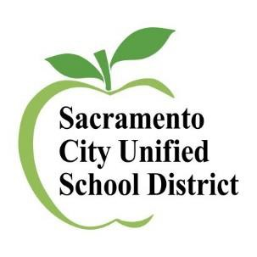
ELAC
Parent Training

All meetings will be on ZOOM.
You only need to attend one session.

1st session 2nd session

Thursday, September 22, 2022 6pm-7pm
https://scusd.zoom.us/j/84519405194
Password: ELAC English w/ Interpreters

Thursday, September 29, 2022
6pm-7pm
https://scusd.zoom.us/j/84519405194
Password: ELAC English w/ Interpreters

3rd sesion

Thursday, October 6, 2022 6pm-7pm
https://scusd.zoom.us/j/84519405194
Password: ELAC
Spanish ONLY

Interpreters will be available for the following languages: Chinese Hmong Vietnamese
Any questions, please contact Multilingual Literacy (916) 643-9446

